Vishwakarma Institute of Technology, Pune
Name : Girish Chinchalpalle
Div : TY - A Roll No. : 56 Batch : 2
PRN No. : 12110567 Assignment No. 2
Subject : Artificial Intelligence

Problem Statement:
Implementation of Uninformed strategies

Graph Coloring
The Graph Coloring Problem is a classic problem in graph theory and computer science. It can be stated as follows: Given an undirected graph, the task is to assign colors to its vertices in such a way that no two adjacent vertices share the same color, while using the fewest possible colors.
Here's a theoretical overview of the problem and some related concepts:
Graph: A graph consists of a set of vertices (nodes) and a set of edges (connections) between these vertices.
Vertex Coloring: This is the process of assigning colors to vertices of a graph subject to certain constraints. In the context of the Graph Coloring Problem, the constraint is that no two adjacent vertices can have the same color.
Greedy Coloring Algorithm: This is one of the simplest algorithms used to color graphs. It iteratively assigns colors to vertices in the order of their appearance in some ordering of the vertices. At each step, the algorithm assigns the smallest possible color that is not already assigned to any adjacent vertex. While simple, this algorithm may not always produce an optimal coloring.

Approach

- Graph Coloring using DFS

- Graph Coloring using BFS

Algorithm
Graph Coloring using DFS:
- Start DFS traversal from any vertex of the graph.
- Assign the first color to the starting vertex.
- While traversing adjacent vertices, assign colors to them such that no adjacent vertices have the same color.
- If all adjacent vertices already have colors assigned, choose a new color for the current vertex.
- Continue this process until all vertices are colored.
Graph Coloring using BFS:
- Start BFS traversal from any vertex of the graph.
- Assign the first color to the starting vertex.
- While traversing adjacent vertices, assign colors to them such that no adjacent vertices have the same color.
- If all adjacent vertices already have colors assigned, choose a new color for the current vertex.
- Continue this process until all vertices are colored.

Real life Examples
The Graph Coloring Problem has numerous real-life applications across various domains. Here are some examples:
Scheduling: In scheduling problems, tasks or events need to be assigned to resources (such as time slots, processors, or workers) in such a way that certain constraints are satisfied. For example, in exam scheduling, exams (tasks) need to be assigned to different time slots (resources) such that no student has conflicting exams. This can be modeled as a graph coloring problem where each exam corresponds to a vertex, and conflicting exams are connected by edges.
Register Allocation in Compilers: Compilers translate high-level programming languages into machine code. Register allocation is a crucial optimization step in compilers where variables in the program need to be assigned to registers in such a way that register usage is minimized and variables are not assigned to the same register if they are live at the same time. This problem can be formulated as a graph coloring problem, where variables are represented as vertices and interference between variables is represented as edges.
Frequency Assignment in Wireless Communication: In wireless communication systems, different frequencies need to be assigned to communication channels to avoid interference between channels. This problem can be modeled as a graph coloring problem, where communication channels are represented as vertices and interference between channels is represented as edges. The goal is to assign frequencies (colors) to channels such that adjacent channels (connected by edges) are assigned different frequencies.
Map Coloring: One of the classical applications of the graph coloring problem is map coloring. Given a map of regions (vertices) with adjacent regions (connected by edges), the goal is to color each region on the map with a color such that no two adjacent regions have the same color. This problem arises in geographical cartography and has applications in political boundary demarcation, scheduling of resources in geographical areas, etc.
Circuit Board Design: In electronic circuit design, components (such as transistors, resistors, capacitors) need to be placed on a circuit board in such a way that certain constraints (such as minimizing wire lengths, avoiding interference) are satisfied. This problem can be formulated as a graph coloring problem, where components are represented as vertices and constraints between components are represented as edges.

Source code
Graph Coloring using DFS:
#include <iostream>
#include <vector>
#include <queue>
#include <algorithm>
using namespace std;

#define V 6

void printSolution(int color[]) {
cout << "Solution Exists: Following are the assigned colors\n";
for (int i = 0; i < V; i++)
cout << " " << color[i] << " ";
cout << "\n";
}

bool isSafe(int v, bool graph[V][V], int color[], int c) {
for (int i = 0; i < V; i++)
if (graph[v][i] && c == color[i])
return false;
return true;
}

bool graphColoringDFSUtil(bool graph[V][V], int m, int color[], int v) {
if (v == V)
return true;

for (int c = 1; c <= m; c++) {
if (isSafe(v, graph, color, c)) {
color[v] = c;
if (graphColoringDFSUtil(graph, m, color, v + 1))
return true;
color[v] = 0;
}
}

return false;
}

bool graphColoringDFS(bool graph[V][V], int m) {
int color[V];
for (int i = 0; i < V; i++)
color[i] = 0;

if (!graphColoringDFSUtil(graph, m, color, 0)) {
cout << "Solution does not exist\n";
return false;
}
printSolution(color);
return true;
}
int main() {
bool graph[V][V] = {
{0, 1, 1, 1, 1, 1},
{1, 0, 1, 0, 1, 0},
{1, 1, 0, 1, 0, 0},
{1, 0, 1, 0, 0, 1},
{1, 1, 0, 0, 0, 1},
{1, 0, 0, 1, 1, 0}
};
int m = 4;

cout << "\nDFS Approach:\n";
graphColoringDFS(graph, m);

return 0;
}

Output:
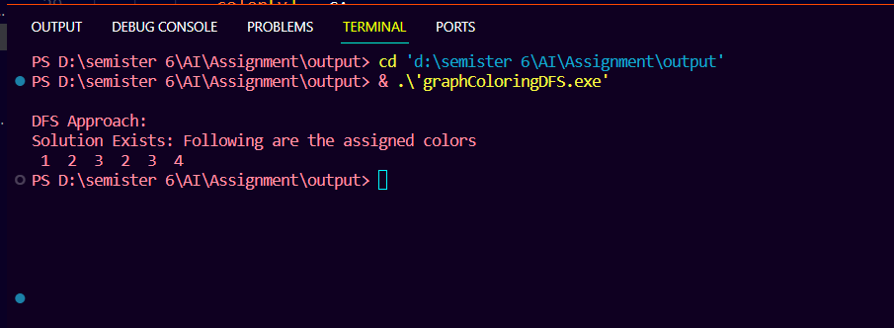

Graph Coloring using BFS:
#include <iostream>
#include <vector>
#include <queue>
#include <algorithm>
using namespace std;

#define V 6

void printSolution(int color[]) {
cout << "Solution Exists: Following are the assigned colors\n";
for (int i = 0; i < V; i++)
cout << " " << color[i] << " ";
cout << "\n";
}

bool isSafe(int v, bool graph[V][V], int color[], int c) {
for (int i = 0; i < V; i++)
if (graph[v][i] && c == color[i])
return false;
return true;
}
bool graphColoringBFS(bool graph[V][V], int m) {
int color[V];
for (int i = 0; i < V; i++)
color[i] = 0;

queue<int> q;
q.push(0);
color[0] = 1;
while (!q.empty()) {
int u = q.front();
q.pop();
int flag =0;
for (int c = 1; c <= m; c++) {
if (isSafe(u, graph, color, c)) {
color[u] = c;
for (int v = 0; v < V; v++) {
if (graph[u][v] && color[v] == 0) {
q.push(v);
color[v] = c;
}
}
flag =1;
}
}
if(flag == 0) {
cout << "Solution does not exist";
return false;
}
}
printSolution(color);
return true;
}
int main() {
bool graph[V][V] = {
{0, 1, 1, 1, 1, 1},
{1, 0, 1, 0, 1, 0},
{1, 1, 0, 1, 0, 0},
{1, 0, 1, 0, 0, 1},
{1, 1, 0, 0, 0, 1},
{1, 0, 0, 1, 1, 0}
};
int m = 4;
cout << "BFS Approach:\n";
graphColoringBFS(graph, m);
return 0;
}

Output: 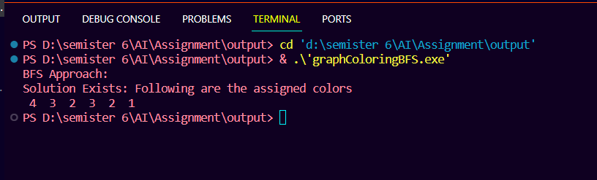

Water jar problem
The Water Jug problem typically involves two jugs of different capacities and a target quantity that needs to be measured. The objective is to find a sequence of operations (e.g., filling, emptying, pouring) that leads to obtaining the desired quantity in one of the jugs.

  - BFS: Starting from the initial state, BFS explores all possible states reachable from it in a level-by-level manner until the goal state is found. It maintains a queue data structure to store the states to be explored next.

Code :-
#include <bits/stdc++.h>
using namespace std;
typedef pair<int, int> pii;
void printpath(map<pii, pii> mp, pii u)
{
if (u.first == 0 && u.second == 0)
{
cout << 0 << " " << 0 << endl;
return;
}
printpath(mp, mp[u]);
cout << u.first << " " << u.second << endl;
}
void BFS(int a, int b, int target)
{
map<pii, int> m;
bool isSolvable = false;
map<pii, pii> mp;
queue<pii> q;
q.push(make_pair(0, 0));
while (!q.empty())
{
auto u = q.front();
// cout<<u.first<<" "<<u.second<<endl;
q.pop();
if (m[u] == 1)
continue;
if ((u.first > a || u.second > b || u.first < 0 || u.second < 0))
continue;
// cout<<u.first<<" "<<u.second<<endl;
m[{u.first, u.second}] = 1;
if (u.first == target || u.second == target)
{
isSolvable = true;
printpath(mp, u);
if (u.first == target)
{
if (u.second != 0)
cout << u.first << " " << 0 << endl;
}
else
{
if (u.first != 0)
cout << 0 << " " << u.second << endl;
}
return;
}
// completely fill the jug 2
if (m[{u.first, b}] != 1)
{
q.push({u.first, b});
mp[{u.first, b}] = u;
}
// completely fill the jug 1
if (m[{a, u.second}] != 1)
{
q.push({a, u.second});
mp[{a, u.second}] = u;
}
// transfer jug 1 -> jug 2
int d = b - u.second;
if (u.first >= d)
{
int c = u.first - d;
if (m[{c, b}] != 1)
{
q.push({c, b});
mp[{c, b}] = u;
}
}
else
{
int c = u.first + u.second;
if (m[{0, c}] != 1)
{
q.push({0, c});
mp[{0, c}] = u;
}
}
// transfer jug 2 -> jug 1
d = a - u.first;
if (u.second >= d)
{
int c = u.second - d;
if (m[{a, c}] != 1)
{
q.push({a, c});
mp[{a, c}] = u;
}
}
else
{
int c = u.first + u.second;
if (m[{c, 0}] != 1)
{
q.push({c, 0});
mp[{c, 0}] = u;
}
}
// empty the jug 2
if (m[{u.first, 0}] != 1)
{
q.push({u.first, 0});
mp[{u.first, 0}] = u;
}
// empty the jug 1
if (m[{0, u.second}] != 1)
{
q.push({0, u.second});
mp[{0, u.second}] = u;
}
}
if (!isSolvable)
cout << "No solution";
}
int main()
{
int Jug1,Jug2,target;
cout<<"\nEnter jug 1 capacity : ";
cin>>Jug1;
cout<<"\nEnter jug 2 capacity : ";
cin>>Jug2;
cout<<"\nEnter target : ";
cin>>target;
cout << "Path from initial state "
"to solution state ::\n";
BFS(Jug1, Jug2, target);
return 0;
}

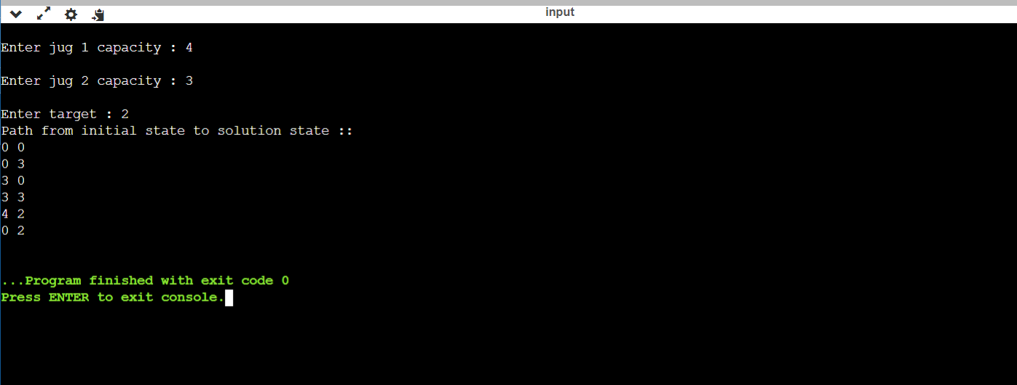
Output :-

  - DFS: Starting from the initial state, DFS recursively explores each branch of the search tree until it reaches a leaf node or the goal state. It uses a stack data structure to keep track of the states to be explored, prioritizing deep exploration over breadth.

Code: -
#include <bits/stdc++.h>
using namespace std;
typedef pair<int, int> pii;
void printpath(map<pii, pii> mp, pii u)
{
if (u.first == 0 && u.second == 0)
{
cout << 0 << " " << 0 << endl;
return;
}
printpath(mp, mp[u]);
cout << u.first << " " << u.second << endl;
}
void DFS(int a, int b, int target)
{
map<pii, int> m;
bool isSolvable = false;
map<pii, pii> mp;
stack<pii> stk;
stk.push(make_pair(0, 0));
while (!stk.empty())
{
auto u = stk.top();
stk.pop();
if (m[u] == 1)
continue;
if ((u.first > a || u.second > b || u.first < 0 || u.second < 0))
continue;
m[{u.first, u.second}] = 1;
if (u.first == target || u.second == target)
{
isSolvable = true;
printpath(mp, u);
if (u.first == target)
{
if (u.second != 0)
cout << u.first << " " << 0 << endl;
}
else
{
if (u.first != 0)
cout << 0 << " " << u.second << endl;
}
return;
}
// completely fill the jug 2
if (m[{u.first, b}] != 1)
{
stk.push({u.first, b});
mp[{u.first, b}] = u;
}
// completely fill the jug 1
if (m[{a, u.second}] != 1)
{
stk.push({a, u.second});
mp[{a, u.second}] = u;
}
// transfer jug 1 -> jug 2
int d = b - u.second;
if (u.first >= d)
{
int c = u.first - d;
if (m[{c, b}] != 1)
{
stk.push({c, b});
mp[{c, b}] = u;
}
}
else
{
int c = u.first + u.second;
if (m[{0, c}] != 1)
{
stk.push({0, c});
mp[{0, c}] = u;
}
}
// transfer jug 2 -> jug 1
d = a - u.first;
if (u.second >= d)
{
int c = u.second - d;
if (m[{a, c}] != 1)
{
stk.push({a, c});
mp[{a, c}] = u;
}
}
else
{
int c = u.first + u.second;
if (m[{c, 0}] != 1)
{
stk.push({c, 0});
mp[{c, 0}] = u;
}
}
// empty the jug 2
if (m[{u.first, 0}] != 1)
{
stk.push({u.first, 0});
mp[{u.first, 0}] = u;
}
// empty the jug 1
if (m[{0, u.second}] != 1)
{
stk.push({0, u.second});
mp[{0, u.second}] = u;
}
}
if (!isSolvable)
cout << "No solution";
}
int main()
{
int Jug1,Jug2,target;
cout<<"\nEnter jug 1 capacity : ";
cin>>Jug1;
cout<<"\nEnter jug 2 capacity : ";
cin>>Jug2;
cout<<"\nEnter target : ";
cin>>target;
cout << "Path from initial state "
"to solution state ::\n";
DFS(Jug1, Jug2, target);
return 0;
}

Output :-
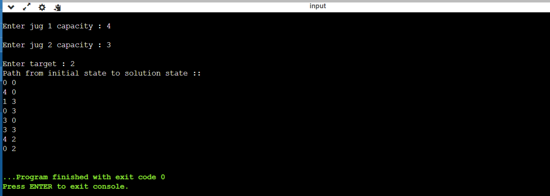

8-puzzle problem
Theory
The 8-puzzle problem is a puzzle that consists of a 3x3 grid with 8 numbered tiles and one blank space. The goal is to rearrange the tiles from a given initial state to a goal state by sliding the tiles into the blank space.
Approach
- BFS: Explore nodes level by level, guaranteeing the shortest path to the goal state.
- DFS: Explore one branch of the tree as deeply as possible before backtracking.
Algorithm
BFS:
- Create a queue and enqueue the initial state.
- While the queue is not empty:
  - Dequeue a node from the queue.
  - If the node is the goal state, return the path.
  - Otherwise, generate all possible successor states and enqueue them if they have not been visited.
- If the queue becomes empty, return failure.
DFS:
- Create a stack and push the initial state.
- While the stack is not empty:
  - Pop a node from the stack.
  - If the node is the goal state, return the path.
  - Otherwise, generate all possible successor states and push them onto the stack if they have not been visited.
- If the stack becomes empty, return failure.
Comparison between BFS and DFS
- Completeness: BFS is complete if the branching factor is finite, and the depth is infinite. DFS is not complete.
- Optimality: BFS is optimal if the cost per step is the same. DFS is not optimal.
- Space Complexity: BFS has higher space complexity due to storing all nodes at each level. DFS has lower space complexity due to backtracking.
- Time Complexity: BFS has higher time complexity as it explores all nodes at each level. DFS has lower time complexity in certain cases, but can get stuck in infinite loops.

Code
BFS
#include <iostream>
#include <algorithm>
#include <vector>
#include <queue>
using namespace std;

class Node
{
public:
vector<Node *> children;
vector<int> initialVector;
Node *parent;

Node(vector<int> _initialVector, Node *_parent)
{
initialVector = _initialVector;
parent = _parent;
}

void printPuzzle(vector<int> vectorValues)
{
int count = 0;
for (auto i : vectorValues)
{
if (count % 3 == 0)
cout << "\n";

cout << i << ' ';
count++;
}
}

int findZero()
{
// Find index of zero in vector
vector<int>::iterator it = find(this->initialVector.begin(), this->initialVector.end(), 0);
return static_cast<int>(distance(this->initialVector.begin(), it));
}

void moveUp()
{
int zPos = this->findZero();
vector<int> temp = this->initialVector;

if (zPos >= 3)
{
swap(temp[zPos], temp[zPos - 3]);
Node *child = new Node(temp, this);
children.push_back(child);
}
}

void moveDown()
{
int zPos = this->findZero();
vector<int> temp = this->initialVector;

if (zPos < 6)
{
swap(temp[zPos], temp[zPos + 3]);
Node *child = new Node(temp, this);
children.push_back(child);
}
}

void moveRight()
{
int zPos = this->findZero();
vector<int> temp = this->initialVector;

if (zPos % 3 < 2)
{
swap(temp[zPos], temp[zPos + 1]);
Node *child = new Node(temp, this);
children.push_back(child);
}
}

void moveLeft()
{
int zPos = this->findZero();
vector<int> temp = this->initialVector;

if (zPos % 3 > 0)
{
swap(temp[zPos], temp[zPos - 1]);
Node *child = new Node(temp, this);
children.push_back(child);
}
}
};
///////
bool isVisited(queue<Node *> queue, Node *currentNode)
{
bool exist = false;

while (!queue.empty())
{
if (queue.front()->initialVector == currentNode->initialVector)
{
exist = true;
}

queue.pop();
}

return exist;
}

void traceSolution(vector<Node *> sol, Node *g)
{
Node *curr = g;
sol.push_back(g);

while (curr->parent != nullptr)
{
curr = curr->parent;
sol.push_back(curr);
}

reverse(sol.begin(), sol.end());

int depth = 0;
for (auto i : sol)
{
depth += 1;
i->printPuzzle(i->initialVector);
cout << "\n";
}

cout << "Depth: " << depth - 1 << endl;
}

class Puzzle
{
private:
std::queue<Node *> queue;
std::queue<Node *> visited;
vector<int> finalVector;
int nodesCount;

public:
Puzzle(vector<int> _initialVector, vector<int> _finalVector)
{
Node *initialNode = new Node(_initialVector, nullptr);
this->queue.push(initialNode);

this->finalVector = _finalVector;
this->nodesCount = 1;
}

void BFS(vector<int> initialVector)
{
vector<Node *> solution;

cout << "Searching for solution..." << endl;

while (!queue.empty())
{
Node *currentNode = this->queue.front();

this->visited.push(currentNode);
this->queue.pop();

currentNode->moveRight();
currentNode->moveUp();
currentNode->moveLeft();
currentNode->moveDown();

this->nodesCount++;

for (auto currentChild : currentNode->children)
{

// If currentChild is equal to finalVector retunr void
if (currentChild->initialVector == this->finalVector)
{
cout << "Solution found :)" << endl;

traceSolution(solution, currentChild);
cout << "Nodes count: " << this->nodesCount << endl;
return;
}

if (!isVisited(this->queue, currentChild) && !isVisited(this->visited, currentChild))
{
this->queue.push(currentChild);
}
}
}
}
};

int main()
{
vector<int> initialVector = {
1, 2, 3,
0, 4, 6,
7, 5, 8};

vector<int> finalVector = {
1, 2, 3,
4, 5, 6,
7, 8, 0};

Puzzle puzzle(initialVector, finalVector);

puzzle.BFS(initialVector);

return 0;
}

DFS:
#include <stack>
#include <iostream>
#include <algorithm>
#include <vector>
#include <chrono>

class Node {
public:
std::vector<Node*> children;
std::vector<int> initialVector;
Node *parent;

Node(std::vector<int> _initialVector, Node *_parent) {
initialVector = _initialVector;
parent = _parent;
}

void printPuzzle(std::vector<int> vectorValues) {
int count = 0;
for (auto i : vectorValues) {
if (count % 3 == 0) std::cout << "\n";

std::cout << i << ' ';
count++;
}
}

int findZero() {
std::vector<int>::iterator it = std::find(this->initialVector.begin(), this->initialVector.end(), 0);
return static_cast<int>(std::distance(this->initialVector.begin(), it));
}

void moveUp() {
int zPos = this->findZero();
std::vector<int> temp = this->initialVector;

if (zPos >= 3) {
std::swap(temp[zPos], temp[zPos - 3]);
Node* child = new Node(temp, this);
children.push_back(child);
}
}

void moveDown() {
int zPos = this->findZero();
std::vector<int> temp = this->initialVector;

if (zPos < 6) {
std::swap(temp[zPos], temp[zPos + 3]);
Node* child = new Node(temp, this);
children.push_back(child);
}
}

void moveRight() {
int zPos = this->findZero();
std::vector<int> temp = this->initialVector;

if (zPos % 3 < 2) {
std::swap(temp[zPos], temp[zPos + 1]);
Node* child = new Node(temp, this);
children.push_back(child);
}
}

void moveLeft() {
int zPos = this->findZero();
std::vector<int> temp = this->initialVector;

if (zPos % 3 > 0) {
std::swap(temp[zPos], temp[zPos - 1]);
Node* child = new Node(temp, this);
children.push_back(child);
}
}
};

bool isVisited(std::stack<Node*> stack, Node* currentNode) {
bool exist = false;

while (!stack.empty()) {
if (stack.top()->initialVector == currentNode->initialVector) {
exist = true;
}

stack.pop();
}

return exist;
}

void traceSolution(std::vector<Node*> sol, Node* g) {
Node* curr = g;
sol.push_back(g);

while (curr->parent != nullptr) {
curr = curr->parent;
sol.push_back(curr);
}

std::reverse(sol.begin(), sol.end());
std::cout << "printing solution" << std::endl;

int depth = 0;
for (auto i : sol) {
depth += 1;
i->printPuzzle(i->initialVector);
std::cout << "\n";
}

std::cout << "Depth: " << depth - 1 << std::endl;
}

class Puzzle {
private:
std::stack<Node*> stack;
std::stack<Node*> visited;
std::vector<int> finalVector;
int nodesCount;

public:
Puzzle(std::vector<int> _initialVector, std::vector<int> _finalVector) {
Node *initialNode = new Node(_initialVector, nullptr);
this->stack.push(initialNode);

this->finalVector = _finalVector;
this->nodesCount = 1;
}

void DFS(std::vector<int> initialVector) {
std::vector<Node*> solution;

std::cout << "Searching for solution..." << std::endl;

while (!this->stack.empty()) {
Node* currentNode = this->stack.top();

this->visited.push(currentNode);
stack.pop();

currentNode->moveRight();
currentNode->moveUp();
currentNode->moveLeft();
currentNode->moveDown();

this->nodesCount++;

for (auto currentChild : currentNode->children) {

// If currentChild is equal to finalVector retunr void
if (currentChild->initialVector == this->finalVector) {
std::cout << "Solution found :)" << std::endl;

// Print solution steps
traceSolution(solution, currentChild);
std::cout << "Nodes count: " << this->nodesCount << std::endl;
return;
}

if (!isVisited(this->stack, currentChild) && !isVisited(this->visited, currentChild)) {
this->stack.push(currentChild);
}
}
}
}

};

int main() {
std::vector<int> initialVector = {
1, 2, 3,
0, 4, 6,
7, 5, 8
};

std::vector<int> finalVector = {
1, 2, 3,
4, 5, 6,
7, 8, 0
};

Puzzle puzzle(initialVector, finalVector);

auto start_time = std::chrono::high_resolution_clock::now();

puzzle.DFS(initialVector);

auto end_time = std::chrono::high_resolution_clock::now();
auto duration_sec = std::chrono::duration<double>(end_time - start_time).count();
std::cout << "Time consumption: " << duration_sec << " seconds" << std::endl;

return 0;
}

OUTPUT:
BFS:
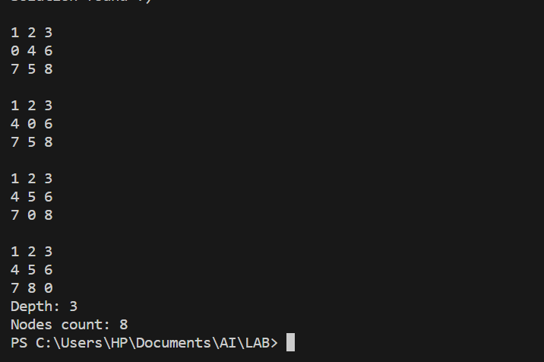
DFS:
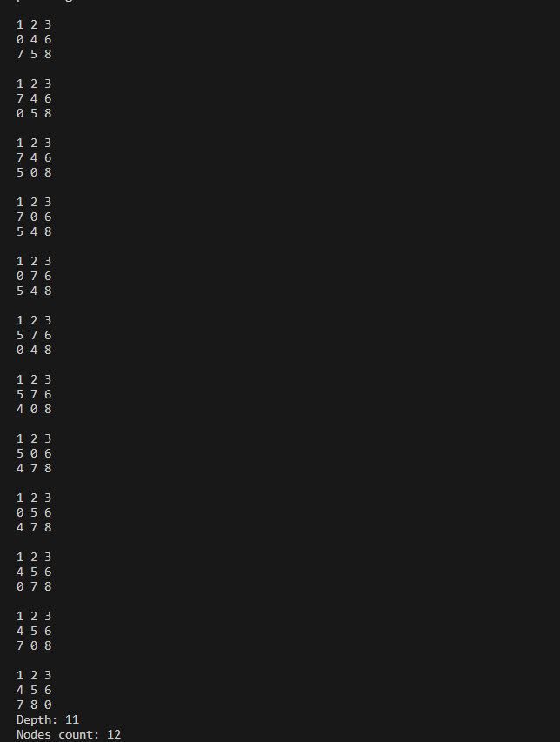

Missionaries and Cannibals Problem

Theory :
Missionaries and Cannibals is a standard problem in which 3 missionaries and 3 cannibals want to cross from the left bank of a river to the right bank of the river. There is a boat on the left bank, but it only carries at most two people at a time (and can never cross with zero people). If cannibals ever outnumber missionaries on either bank, the cannibals will eat the missionaries. A state can be represented by a triple, (m c b), where m is the number of missionaries on the left, c is the number of cannibals on the left, and b indicates whether the boat is on the left bank or right bank. The initial state is (3 3 L) and the goal state is (0 0 R).
a. BFS:
function BFS(initial_state, goal_state): frontier = Queue() explored = Set()
frontier.enqueue(initial_state)

while not frontier.isEmpty(): state = frontier.dequeue()
explored.add(state)

if state == goal_state: return reconstruct_path(state) # Function to trace back solution path

for successor in generate_valid_successors(state): if successor not in explored: frontier.enqueue(successor)

return "No solution found"

function generate_valid_successors(state):
# Implement logic to generate all possible valid successor states based on the current state information
# (e.g., number of missionaries and cannibals on each side, boat position)
# Ensure generated states follow the safety rule (missionaries not outnumbered by cannibals)
# Return a list of valid successor states

function reconstruct_path(state):
# Implement logic to backtrack and reconstruct the solution path from the final state
# Return the solution path as a sequence of states

b. DFS:
function DFS(initial_state, goal_state): frontier = Stack() explored = Set() frontier.push(initial_state)

while not frontier.isEmpty():
state = frontier.pop()
explored.add(state)

if state == goal_state: return reconstruct_path(state) # Function to trace back solution path

for successor in generate_valid_successors(state): if successor not in explored: frontier.push(successor)

return "No solution found"

function generate_valid_successors(state):
# Implement logic to generate all possible valid successor states based on the current state information
# (e.g., number of missionaries and cannibals on each side, boat position)
# Ensure generated states follow the safety rule (missionaries not outnumbered by cannibals)
# Return a list of valid successor states

function reconstruct_path(state):
# Implement logic to backtrack and reconstruct the solution path from the final state
# Return the solution path as a sequence of states

Code
BFS:
#include <iostream>
#include <vector>
#include <queue>
#include <unordered_set>

using namespace std;

// Class representing each state of the state space.
class State {
public:
int value[3]; // Values in the form of [M, C, B], where M = missionaries, C = cannibals, and B = boats on the left side
vector<State*> childStates; // Child states

// Constructor to initialize the state using an integer array
State(int* v) {
for (int i = 0; i < 3; i++) {
this->value[i] = v[i];
}
}

// Constructor to initialize the state using individual values
State(int m, int c, int b) {
this->value[0] = m;
this->value[1] = c;
this->value[2] = b;
}

// Function to add a child state to the tree
void addChild(State* c) {
this->childStates.push_back(c);
}

// Function to print the current state
void printState() {
cout << "(" << value[0] << "," << value[1] << "," << value[2] << ")";
}

// Function to check the equality between two states
bool operator==(State s) {
return (this->value[0] == s.value[0] && this->value[1] == s.value[1] && this->value[2] == s.value[2]);
}
};

// Function to check if the given state will pose a cannibal situation on either side of the river
bool isCannibal(State* checkState) {
return ((checkState->value[0] < checkState->value[1] && checkState->value[0] != 0) ||
(checkState->value[0] == 2 && checkState->value[1] == 1) ||
(checkState->value[0] == 2 && checkState->value[1] == 0));
}

// Function to generate all possible states from the current state
vector<State*> stateGenerator(State* current) {
vector<State*> childStates;
int ltr[5][3] = {{0,1,1}, {1,0,1}, {0,2,1}, {2,0,1}, {1,1,1}}; // Operations
State* tempState;

if (current->value[2] == 1) {
for (int i = 0; i < 5; i++) {
tempState = new State(current->value[0] - ltr[i][0], current->value[1] - ltr[i][1], current->value[2] - ltr[i][2]);
if (tempState->value[0] < 0 || tempState->value[1] < 0 || tempState->value[2] < 0) continue;
if (tempState->value[0] > 3 || tempState->value[1] > 3 || tempState->value[2] > 1) continue;
if (isCannibal(tempState)) continue;
childStates.push_back(tempState);
}
} else {
for (int i = 0; i < 5; i++) {
tempState = new State(current->value[0] + ltr[i][0], current->value[1] + ltr[i][1], current->value[2] + ltr[i][2]);
if (tempState->value[0] < 0 || tempState->value[1] < 0 || tempState->value[2] < 0) continue;
if (tempState->value[0] > 3 || tempState->value[1] > 3 || tempState->value[2] > 1) continue;
if (isCannibal(tempState)) continue;
childStates.push_back(tempState);
}
}
return childStates;
}

// Function to generate the entire state space tree using BFS
void generateTree(State* initialState) {
queue<State*> bfsQueue;
unordered_set<string> visited;
bfsQueue.push(initialState);
visited.insert(to_string(initialState->value[0]) + to_string(initialState->value[1]) + to_string(initialState->value[2]));

while (!bfsQueue.empty()) {
State* currentState = bfsQueue.front();
bfsQueue.pop();
vector<State*> derivedStates = stateGenerator(currentState);

for (auto& newState : derivedStates) {
if (visited.find(to_string(newState->value[0]) + to_string(newState->value[1]) + to_string(newState->value[2])) == visited.end()) {
currentState->addChild(newState);
bfsQueue.push(newState);
visited.insert(to_string(newState->value[0]) + to_string(newState->value[1]) + to_string(newState->value[2]));
} else {
delete newState;
}
}
}
}

// Function to print the entire tree or a subtree
void printTree(State* node) {
if (node->childStates.empty()) {
return;
}
cout << "Parent: ";
node->printState();
cout << endl;
for (auto child : node->childStates) {
child->printState();
}
cout << endl << endl;
for (auto child : node->childStates) {
printTree(child);
}
}

int main() {
State* initialState = new State(3, 3, 1); // Start State
generateTree(initialState);

cout << "The state space tree has been generated using BFS." << endl;
cout << "Printing the entire tree structure:" << endl;
printTree(initialState);

return 0;
}

Output:

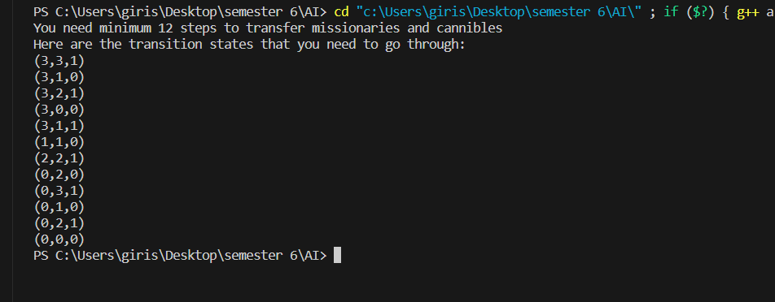

DFS:
#include <iostream>
#include <string>
#include <vector>
#include <stack>
#include <algorithm>
using namespace std;
/**This class will be represnting each state of the state space.
* */
class State {
public:
///will store values in form of [M, C, B] whicih stands for
///missionaries, cannibals, and boats on the left side
int value[3];
///will be used to store child states
vector <State*> childStates;

/** This constructor can be used to intialize the state uisng an
* integer array
* @arg v adrress of an integer array containing three elemnts.
*/
State(int* v) {
//ctr
for(int i = 0; i < 3; i++) {
this->value[i] = v[i];
}
}

/** This constructor can be used to intialize the state uisng an
* integer array
* @arg m number of misionaries
* @arg c number of cannibals
* @arg b where is the boat? 1: left bank, 0: right bank
*/
State(int m, int c, int b) {
//ctr
this->value[0] = m;
this->value[1] = c;
this->value[2] = b;
}

/** @brief add a child state to the tree
* @arg c state
* */
void addChild(State* c) {
this->childStates.push_back(c);
}

/**can be used to print the current state.
* */
void printState() {
cout << "(" << value[0] << "," << value[1] << "," << value[2] << ")";
}

/***Checks the equality between two states
* */
bool operator==(State s) {
if(this->value[0] == s.value[0]
&& this->value[1] == s.value[1]
&& this->value[2] == s.value[2]) {
return true;
} else {
return false;
}
}

/***Checks inequality between two states
* */
bool operator!=(State s) {
if(this->value[0] == s.value[0]
&& this->value[1] == s.value[1]
&& this->value[2] == s.value[2]) {
return false;
} else {
return true;
}
}

/*** Decrements all values in the state by 1
* @arg a an integer array
* */
void operator-=(int* a) {
for(int i = 0; i < 3; i++) {
value[i] -= a[i];
}
}

/*** Increments all values in the state by 1
* */
void operator+=(int* a) {
for(int i = 0; i < 3; i++) {
value[i] += a[i];
}
}
};

bool isCanibal(State* checkState) {
if((checkState->value[0] < checkState->value[1]
&& checkState->value[0]!= 0)
|| checkState->value[0] == 2
&& checkState->value[1] == 1
|| checkState->value[0] == 2
&& checkState->value[1] == 0)
return true;
return false;
}

vector<State*> stateGenerator(State* current) {
vector<State*> childStates;
int ltr[5][3] = {{0,1,1},
{1,0,1},
{0,2,1},
{2,0,1},
{1,1,1}}; //operations
State* tempState;
// check if already at the goalstate
State goalState(0,0,0);
if(goalState == *current)
return childStates;

//if boat is on left bank
if(current->value[2] == 1) {
for(int i = 0; i < 5; i++) {
tempState = new State(current->value[0] - ltr[i][0],
current->value[1] - ltr[i][1],
current->value[2] - ltr[i][2]);
if(tempState->value[0] < 0
|| tempState->value[1] < 0
|| tempState->value[2] < 0)
continue;
if(tempState->value[0] > 3
|| tempState->value[1] > 3
|| tempState->value[2] > 1)
continue;
if(isCanibal(tempState))
continue;
childStates.push_back(tempState);
}
}else {
//if boat is on right bank
for(int i = 0; i < 5; i++) {
tempState = new State(current->value[0] + ltr[i][0],
current->value[1] + ltr[i][1],
current->value[2] + ltr[i][2]);
if(tempState->value[0] < 0
|| tempState->value[1] < 0
|| tempState->value[2] < 0)
continue;
if(tempState->value[0] > 3
|| tempState->value[1] > 3
|| tempState->value[2] > 1)
continue;
if(isCanibal(tempState))
continue;
childStates.push_back(tempState);
}
}
return childStates;
}

vector<State*> alreadyDiscovered;// used to store already discovered nodes

void generateTree(State* currentState) {
vector<State*> derivedStates = stateGenerator(currentState);
//no new states from here
if(derivedStates.size() == 0)
return;
//remove already discovered states
for(int i = 0; i < alreadyDiscovered.size(); i++) {
for(int j = derivedStates.size()-1; j >= 0; j--) {
if(*alreadyDiscovered.at(i) == *derivedStates.at(j)) {
delete derivedStates.at(j);
derivedStates.erase(derivedStates.begin()+j);
}
}
}
//add new states to the parent nodes.
for(auto& a: derivedStates) {
currentState->addChild(a);
alreadyDiscovered.push_back(a);
}

for (auto& a: currentState->childStates) {
generateTree(a);
//if the goal state is found, no need to search further
if(a->value[0] == 0 && a->value[0] == 0 && a->value[0] == 0)
break;
}
}

void printTree(State* node) {
if(node->childStates.size() == 0) {
return;
}
cout << "parant: "; node->printState(); cout << endl;
for(auto a: node->childStates) {
a->printState();
}
cout << endl << endl;
for(auto a: node->childStates) {
printTree(a);
}
}

void dfs(State* currentState, State* goalState
, stack<State*, vector<State*>> * path) {
path->push(currentState);
if(*currentState != *goalState && !currentState->childStates.empty()) {
for (auto c: path->top()->childStates) {
dfs(c, goalState, path);
}
} else{
if(*currentState != *goalState){
path->pop();
}
}
}

int main() {
State* initialState = new State(3, 3, 1); ///Start State
State* goalState = new State(0, 0, 0);
stack<State*, vector<State*>> dfsStack;
alreadyDiscovered.push_back(initialState);
generateTree(initialState);
dfs(initialState, goalState, &dfsStack);
stack<State*, vector<State*>> printStack; //temporary stack to format output
//print reverseing the stack for printing
while(!dfsStack.empty()){
printStack.push(dfsStack.top());
dfsStack.pop();
}
//output of the program
cout << "You need minimum "
<< printStack.size()
<< " steps to transfer missionaries and cannibles" << endl;
cout << "Here are the transition states that you need to go through: "
<< endl;
while(!printStack.empty()){
printStack.top()->printState(); cout << endl;
printStack.pop();
}
return 0;
}

Output:

